A-level ICT
SENIOR Five term 2
TOPIC 1/2: Computer Hardware
Competency: The learner performs routine service on computer hardware to ensure its optimal functionality and performance.
Computer hardware
Computer hardware is the collection of physical parts that make up a computer.
Classification of Computer Hardware Components

(i) Input Devices
Input devices are computer hardware components that allow users to enter data, instructions, or signals into a computer system for processing.
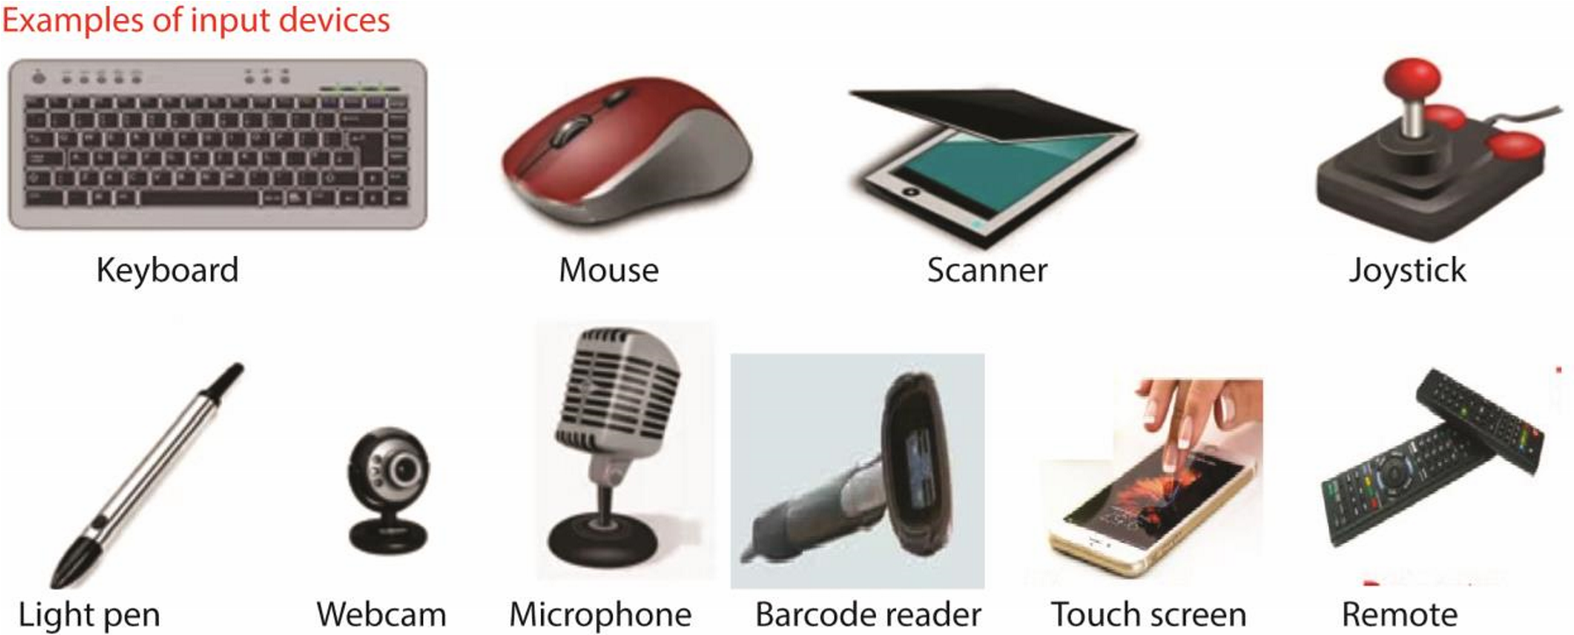
- Keyboard – allows users to type text, numbers, and commands into the computer.
- Mouse – controls the pointer on the screen, used for clicking, selecting, and dragging items.
- Scanner – converts physical documents or images into digital format.
- Joystick – controls movement or actions in a computer system or electronic device.
- Light pen – allows users to point, draw, or select objects directly on the screen.
- Webcam – records video and takes pictures for video calls or media creation.
- Microphone – captures audio input for recording or communication.
- Barcode reader/barcode scanner – captures and interprets information stored in barcodes. It helps computers quickly identify products, track inventory, and process transactions.
- Touchscreen – lets users interact directly with the display by touching it.
- Remote (remote control) – operate electronic equipment from a distance without direct contact.

(ii) Output Devices
Output devices are computer hardware components that present processed information to the user in a readable or usable form. They take data from the computer and convert it into text, images, audio, or other formats.
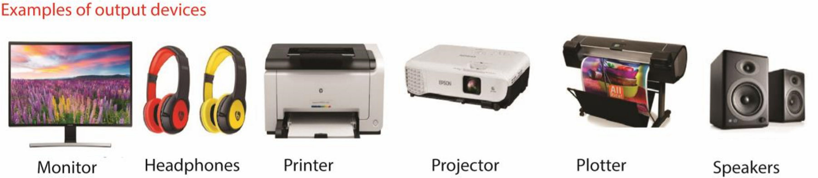
- Monitor – displays text, images, and videos.
- Headphones – output sound
- Printer – produces hard copies of documents.
- Projector – enlarges visual output for audiences.
- Speakers – output sound.
- Plotter - produce high-quality graphics, drawings, and large-scale prints. Unlike regular printers, plotters draw continuous lines using pens, making them ideal for technical and engineering applications.

(iii) Storage Devices
Storage devices store data permanently or temporarily.
Examples:
- Hard Disk Drive (HDD) – long-term storage of files and programs.
- Solid State Drive (SSD) – faster, durable storage.
- USB Flash Drive – portable storage.
- RAM (Random Access Memory) – temporary storage for active processes.
- CD/DVD - store digital data such as music, videos, software, or documents.
- Memory card - store digital data such as photos, videos, music, and documents.
- Smart card - contains an embedded microchip used to store and process data securely.
- Floppy disk - saves and transfer small amounts of data.
- Tape – store data

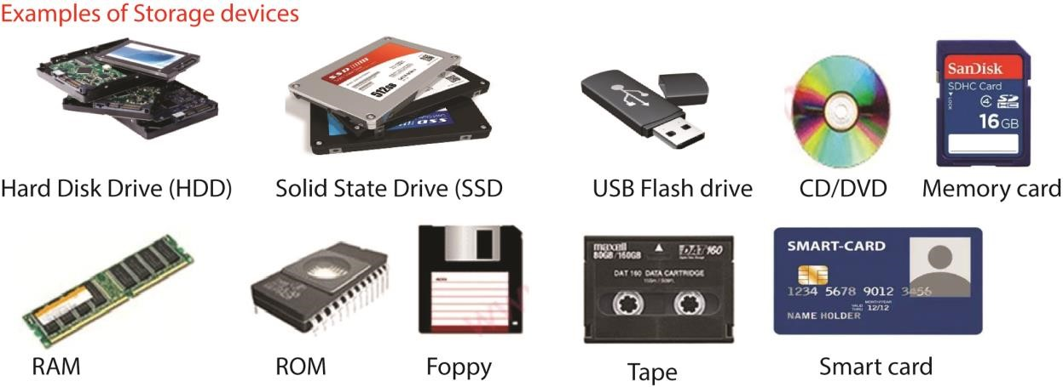

(iv) Processing Devices
Processing devices are devices that perform calculations and execute instructions.
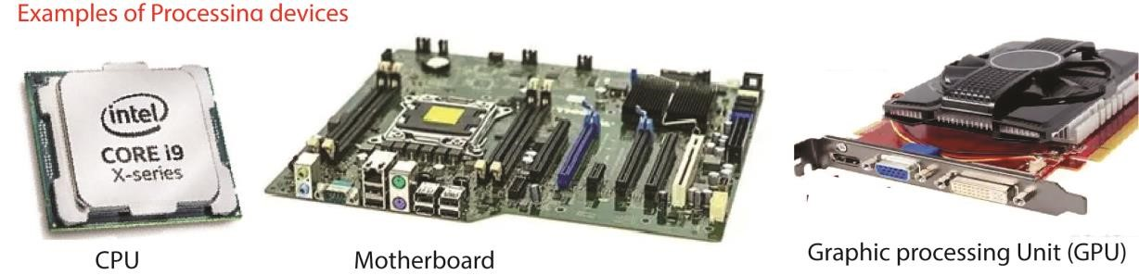
- Central Processing Unit (CPU) – the “brain” of the computer, handles all instructions.
- Motherboard – main circuit board connecting all components.
- Graphics Processing Unit (GPU) – handles image and video rendering.

(v) Communication Devices
These enable data exchange between computers or networks.
- Network Interface Card (NIC) – connects computer to a network.
- Modem – converts signals for internet access.
- Router – directs data between networks.
- Wi-Fi Adapter – enables wireless connectivity.
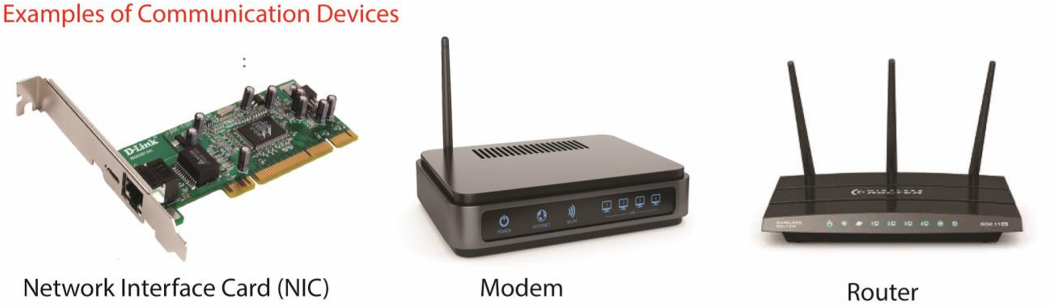

Summary Table of computer hardware components
Category | Function | Examples
Input Devices | Enter data into computer | Keyboard, Mouse, Scanner
Output Devices | Display results to user | Monitor, Printer, Speakers
Storage Devices | Store data | HDD, SSD, RAM, USB
Processing Devices | Execute instructions | CPU, GPU, Motherboard
Communication Devices | Exchange data | NIC, Modem, Router

Task

Assemble a computer system from hardware components ensuring correct connections and configurations.
Steps to Assemble a Computer System
- Prepare Workspace o Clean, static-free surface.
  - Use an anti-static wrist strap to avoid damaging components.
- Install the Motherboard o Place the motherboard inside the case.
  - Secure it with screws on standoffs (to prevent short circuits).
- Install the CPU (Processor) o Open the CPU socket latch. o Align the CPU with the socket (triangle markers help). o Lock it in place. o Apply thermal paste (if not pre-applied). o Attach the CPU cooler/fan.
- Insert RAM (Memory) o Open RAM slots. o Align RAM sticks with notches.
  - Press firmly until they click into place.
- Install Storage Devices o HDD/SSD: mount in drive bays or M.2 slot.
  - Connect SATA or NVMe cables to motherboard.
- Install Power Supply (PSU) o Secure PSU in the case. o Connect 24-pin ATX cable to motherboard.
  - Connect 8-pin CPU power cable.
  - Connect power cables to GPU, drives, and fans.
- Install Graphics Card (if needed) o Insert GPU into PCIe slot. o Secure with screws.
  - Connect power cables from PSU.
- Connect Case Components o Front panel connectors (power button, reset, USB, audio).
  - Case fans to motherboard headers.
- Final Checks o Ensure all cables are firmly connected. o Verify CPU cooler and case fans are installed correctly.
  - Close the case.
- Power On & Configure BIOS o Connect monitor, keyboard, and mouse. o Power on system. o Enter BIOS/UEFI to check hardware recognition.
  - Set boot order (e.g., USB or SSD).
- Install Operating System o Use bootable USB/DVD. o Follow installation steps.
  - Install drivers for motherboard, GPU, and peripherals.

Quick Checklist
Component | Connection
CPU | Socket + cooler
RAM | DIMM slots
Storage (HDD/SSD) | SATA/NVMe to motherboard
GPU | PCIe slot + PSU cables
PSU | 24-pin ATX + 8-pin CPU + GPU power
Case Fans | Fan headers on motherboard
Front Panel | Power/reset/USB/audio connectors
Routine maintenance activities of computer
Keeping a computer in good condition requires regular maintenance to ensure smooth performance, prevent failures, and extend its lifespan. Here are the key activities:

Hardware Maintenance
- Dust cleaning – remove dust from CPU, keyboard, monitor, and fans to prevent overheating.
- Check cables and connections – ensure power and data cables are firmly attached.
- Inspect peripherals – test mouse, keyboard, printer, and other devices for proper functioning.
- Cooling system check – verify fans and heat sinks are working to avoid overheating.
- Battery care (laptops/UPS) – check battery health and replace if necessary.

Software Maintenance
- Update operating system – install the latest patches for security and performance.
- Update drivers – keep hardware drivers current for compatibility.
- Run antivirus scans – detect and remove malware regularly.
- Clean temporary files – delete cache, cookies, and unnecessary files to free space.
- Defragment hard drive (for HDDs) – reorganize data for faster access.
- Backup data – regularly save important files to external drives or cloud storage.

Network & Security Maintenance
- Check firewall settings – ensure protection against unauthorized access.
- Update passwords – change regularly to maintain security.
- Monitor internet connectivity – troubleshoot slow or unstable connections. • Secure Wi-Fi – use strong encryption (WPA2/WPA3).
Common Computer Troubleshooting Issues & Solutions
Troubleshooting computer problems involves identifying the issue and applying systematic solutions, starting with the simplest checks.
Here are common computer problems and their respective solutions:
- Computer Will Not Turn On
This is usually a power-related issue.
  - Check power connections: Ensure the power cable is securely plugged into both the computer and a working wall outlet. If using a power strip or surge protector, bypass it and plug directly into the wall outlet.
  - Verify power source: Test the outlet with another device (like a lamp). For a laptop, make sure the battery is charged and try connecting with the AC adapter only (if the battery is removable).
  - Listen for sounds/lights: If there are no lights or fan sounds, the power supply unit (PSU) may be faulty.
  - Disconnect peripherals: Sometimes a faulty external device (printers, USB drives, etc.) can prevent startup. Disconnect all of them and try powering on again.
- Slow Performance
Slowdowns can result from insufficient resources or background processes.
  - Restart the computer: A simple restart clears the system memory (RAM) and ends errant processes.
  - Manage startup programs: Disable unnecessary applications from running automatically at startup using the Task Manager (Ctrl + Shift + Esc on Windows) or Activity Monitor (on Mac).
  - Free up disk space: A hard drive that is over 85% full can significantly slow down performance. Use built-in tools like Disk Cleanup (Windows) or Storage Management (macOS) to remove temporary files and unused programs.
  - Run a malware scan: Viruses and malware can consume significant system resources. Run a full scan with reputable antivirus software.
  - Consider hardware upgrades: If the problem persists, you may need more RAM or an upgrade from an HDD to a solid-state drive (SSD).
- 3. Computer Freezing or Unresponsive
A frozen computer typically requires you to force-quit applications or force a restart.
  - Force quit an application: In Windows, press Ctrl + Alt + Delete or Ctrl + Shift + Esc to open the Task Manager, select the unresponsive application, and click "End task". On a Mac, press Command + Option + Esc to open the Force Quit menu.
  - Force a shutdown: If the whole system is unresponsive, press and hold the power button for 5-10 seconds until the computer completely turns off. Wait a few seconds, then restart it.
  - Boot into Safe Mode: If freezing is constant, boot into Safe Mode (which loads only essential drivers) to diagnose if a specific driver or software is causing the problem.
- 4. No Internet Connection
Connectivity problems often stem from network hardware or settings.
  - Check physical connections: Ensure all Ethernet cables are securely plugged in. For Wi-Fi, make sure wireless capabilities are enabled on your computer.
  - Restart network equipment: Power cycle your modem and router. Unplug them, wait about 30 seconds, then plug the modem back in. Once it's fully on, plug in the router.
  - Run the troubleshooter: Use the built-in Windows Network Troubleshooter or Mac's Wireless Diagnostics to automatically identify and fix common issues.
  - Contact your ISP: If all local troubleshooting fails, the problem may be an outage or issue with your Internet Service Provider.
- 5. Blue Screen of Death (BSOD) or Crashing
These critical errors are often caused by driver conflicts, faulty hardware, or corrupted system files.
  - Note the error code: Write down the "stop code" displayed on the screen and search for it online to find specific solutions.
  - Boot into Safe Mode: This allows you to troubleshoot without non-essential drivers or software running.
  - Update or roll back drivers: Faulty or outdated drivers are a common cause. Update your graphics, chipset, and network drivers, or roll back recently updated ones in Device Manager.
  - Scan for malware: Run a full system virus scan.
sfc /scannow
  - Run system file checker: Use the Command Prompt command to check for and repair corrupted Windows system files.
- PC Overheating
Cause: Dust buildup, poor ventilation, or faulty cooling fans.
Solution: Clean dust from vents, ensure proper airflow, replace or repair fans.
- Noisy Computer
Cause: Dust in fans, failing hard drive, or loose components.
Solution: Clean fans, check hard drive health, tighten screws.

TOPIC 2/2: Computer Software
Competency: The learner installs and maintains computer software to ensure optimal functionality and performance.

Programs and software
Program and software are instructions given to the computer to perform a specific task
A program is a small block of code or a set of instruction the system to do its task
Software is a set of programs which instructs computer just like program does. But the functionalities and features of software are more complex compared to that of a program.

Types of software
1. System software
System Software is the type of software that is the interface between application software and the system
Features of system software
- System Software is closer to the system
- Generally written in a low-level language
- The system software is difficult to design and understand
- Fast in speed
- Less interactive
- Smaller in size
- Hard to manipulate
Examples of System Software
- Operating system manages hardware, software resources, and provides common services for computer programs.

Functions of operating system
  - manages files,
  - manages memory,
  - manages processes,
  - handles input and output,
  - controls peripheral devices like disk drives and printers
  - provide the interface between computer hardware and peripheral devices - Configuring devices.
  - Accomplish booting processes - Monitoring system performance. - Administering security.
Examples of operating systems
(a) Microsoft Windows
Advantages of windows operating system
    - User-friendly graphical user interface (GUI).
    - Wide range of compatible software and applications.
    - Extensive hardware support for various devices.
    - Regular updates and security patches for improved performance. - Familiarity, as it's a widely used operating system. - Standard operating system for high-end gaming
    - Available at different configurations and price points
Disadvantages of windows operating system
    - Security Vulnerabilities. One of the most significant drawbacks of the Windows Operating System is its vulnerability to security threats such as viruses, malware,
    - High Resource Requirements such as higher RAM, advanced processors, and substantial storage space - Are expensive.
    - Frequent Updates be disruptive, requiring significant installation time and system restarts.
    - Compatibility Issues: new window versions are incompatible with older applications and hardware
    - Privacy Concerns.
    - System Stability: some window features are unstable leading to data loss
    - Bloatware/unnecessary pre-installed software that consumes space and sometimes slowing the computer
    - Limited customization can be a drawback for users who wish to tailor their operating system to their specific needs and preferences.
    - Licensing Restrictions limits distribution and use
(b) Linux Operating System

Advantages of Linux Operating system
    - Open-source nature: Linux is freely available and customizable.
    - Security: Linux is more secure than other operating systems.
    - Easy and frequent software updates.
    - Variety of distributions: Choose from various Linux distributions based on your requirements.
    - Cost-effectiveness: Linux is freely available on the internet.
    - Stable
Disadvantages of Linux operating system
    - Steeper learning curve compared to other operating systems.
    - Limited software availability.
    - Hardware compatibility issues.
    - Lack of standardization.
    - Difficult setup, installation, and use for inexperienced users.
  - Apple mac OS
  - Google's Android OS
  - Apple iOS
- Drivers allow operating system to communicate with hardware devices like printer, graphic cards, network adapters etc.
- Utility software performs tasks to enhance productivity, efficiency, functionality, or maintenance of a computer system to ensure the system runs smoothly.
Example of Utility software
    - Antivirus software for virus protection.
    - Disk cleanup
    - File management tools for managing files.
    - Compression tools for reducing file size.
    - Disk management tools for managing storage.
    - Debuggers for examination and modifying data

- Firmware is low-level software embedded in hardware devices, providing control and communication between the devices and other system components.
- Boot loaders are responsible for loading operating system into computer’s memory when the system is powered on
- Language processors/translators translate high-level programming languages into machine codes that the computer can execute.
Types of programming language translators
    - Interpreters convert high-level language to machine language line by line.
    - Compilers convert entire high-level language programs to machine language at once. - Assemblers translate assembly language programs to machine language.
Compiler, interpreter, and assembler are different in that the compiler In contrast, an interpreter The assembler
    - Resource allocation is system software that allocate resources like CPU time, memory space and input/output devices to various programs and users
    - Security and Access control ensures that unauthorized user does not access the system and that data is protected from corruption and loss.
    - Communication Software: Communication software allows us to transfer data and programs from one computer system to another.

2. Application software
Application Software is a program that is created to perform a specific task for a user.
Feature of Application Software:
- Perform more specialized tasks like word processing, spreadsheets, email, photo editing, etc.
- It needs more storage space as it is bigger in size
- Easy to design and more interactive for the user
- Generally written in a high-level language

Qualities of good application software
- Functionality: It refers to the degree of performance of the software.
- Reliability: A set of attribute that Bear on the capability of software to.
- Efficiency: It refers to the ability of the software to use System.
- Usability: It refers to the extent to which the software can be used with.
- Maintainability: Refers to the ease with which the modifications can be made in a software system to extend its functionality, improvement, performance or correct errors. Maintainability covers Testability, Stability, Changeability, Analyzability.
- Robustness: It refers to the degree to which the software can keep on functioning in spite of being provided with invalid data.
- Integrity: It refers to the degree to which Unauthorized Access to the software data can be prevented.
Examples of application software
- Word processing software
- Graphic software
- Spreadsheet software
- Presentation software
- Database software
- Web browsers
- Multimedia software

- A word processor is software program that lets users create, edit, print, and save text documents. This allows a user to create and manipulate documents that contain text and graphics.
Examples of word processing software:
Microsoft word, Word pad, AmiPro, PC Write, Mac Write, Lotus word, Pro Notepad, Word star, Corel word perfect, Microsoft, pocket word
Uses of word processor
  - document creation: letters, report, resume, stories and essays
  - edits and formats documents
  - provides templates for documents like business letters, invoices etc.
  - mail merge: automating the process of sending personalized letter or email to multiple recipients
  - Creates academic papers and articles
  - Creates tables charts and lists of organized information effectively
  - Automatically checks and corrects spelling and grammatical errors
Advantages of processor document
  - Easily edited
  - Easily stored and retrieved
  - Shared easily
- Spreadsheet software organizes data in rows and column and also performs calculations.
Examples of spread sheet software include: Microsoft excel, Corel Quattro pro, Lotus 123, Microsoft pocket.
Uses spreadsheet software
  - For budgeting and financial management
  - For inventory management
  - To facilitate data analysis by creating charts and graphs to
  - To analyze research data
  - Used to create financial statements
  - Used to prepare statistical reports

Advantages of spreadsheet software in preparing budgets
  - Offer limitless customization

Handles vast amount of data
  - Makes adjustment of figures easy
  - Organizes and makes tracking of income and expenditure easy
  - Makes calculation easy
  - Provide flexibility in how to manage and analyze the budget
  - Enhances visualization through use graphs
  - Provides storage and easy accessibility options
  - Cheap because most spread software like Google Sheets is free

- Desktop publishing software is used to create the following: Text books Corporate news letters
Marketing literature Product catalogues Annual reports Business cards Calendars Flyers
Features of desktop publishing software include
  - Text tools that allow creation of documents with various fonts, text wrapping, drop caps and paragraph styles
  - Graphic tools for easy insertions and edit of images
  - Page layout tools such as grinds and guides to align elements precisely on page and use of layers to organize different elements on separate layer to easier editing and complex designing.
  - Provision for master templates with consistent headers, footers and other repeating elements
  - Interactive elements such as hyperlinks and multimedia integration tools for audio and videos into a document.
  - Provision of stylish templates for brand development and maintenance.
- Data management software/database, defines, creates, edits and manages vast amounts of data databases.
Examples of database software: Microsoft access, Claris file marker pro, D-base, Fox pro,
Paradox, Oracle
Features of database
  - Data Storage and Management: it enables storage, retrieval and management of large volume data.
  - Data Security: Database software protects data form unauthorized access and cyber threats. It includes features for data encryption, access control and regular backups to ensure data integrity and security.
  - Data Analysis and Reporting: it enables users to perform complex queries and generate reports
  - Multi-user Access: it supports concurrent access by multiple users, allowing team to collaborate and access the same data simultaneously
  - Web Application: many web applications rely on database to store user data, preferences and activity logs
Backup and Recovery: Database software contains tools for backing up data and recovering it in case of hardware failure.
  - Data Integration: it can integrate data from various sources, providing a unified view of information.
  - Scalability: modern database software can handle increasing amounts of data and users, making it suitable for growing businesses and applications.
- Presentation software is used to combine text, graphics, animations, audio and video in presentation
Examples of presentation software: Microsoft PowerPoint, Google slide, Keynote
Uses Presentation software
    - Teaching - Lectures
    - Demonstration
    - Project report
    - Workshops
    - Marketing reports
    - training
- Web browsers: a web browser is a program used to access and view websites or website information.
Example of web browsers: Google chrome, opera, Internet Explorer, Mozilla Firefox
- A multimedia program, multimedia application, or any multimedia software is software that plays or records and creates audio and video files.

3. Tailor-made software
It is software that is developed specifically for some specific organization or other user.

4. Off-shelf programs/software
Off-the-shelf/ out-of-the-box software is ready-made software, usually commercial, designed to serve a broad audience with common needs.
Examples of off-self software
- Editor programs- examples include Photoshop, Lightroom, Facetune
- Mail services- examples include Gmail, Outlook, Zohomail
- Media players- examples are VLC, Windows Media player
- Operating systems- examples are Windows, Mac
- Electronic Mail: Enables messages to be sent over an internet connection. Examples of these kinds of software include Gmail (Google), Yahoo Mail, and Hotmail (Microsoft).
Anti-Virus Software: These types of software applications have been developed to protect computer systems from malicious software programs. Examples include Norton and Kaspersky.
- Customer Relationship Management: As the name suggests, CRM software like Salesforce and Hubspot are used by businesses to manage relationships with their customers.
- Graphic Design: These software applications help users create graphics, manipulate images, and touch-up photos, among other functions. Adobe Photoshop, Illustrator, Canva, and Figma are well-known examples of the software.
- Communication: Software like WhatsApp, Slack, and Microsoft Teams enable communication in real-time between people in different parts of the globe.
- Task Management: ClickUp and Trello are two examples of task management software used by (usually remote) teams to track tasks.

Elements of the “off-the-shelf” software
- They are standardized programs that massively produced and ready for use
- They are not explicitly tailored but rather universal and made for widespread business use
- Are easily integrated with existing systems without complex configurations.

Advantages of off-self software
- Lower initial cost and cost-effectiveness
- Quicker and easier to implement and use
- Proven reliability and quality
- Regular updates and support
- Available training resources and community support
- Owned by someone else, so they foot the development/upgrade costs

Disadvantages of off-self software
- Lack of customization: off-self software are designed for wide audience and may not meet specific needs.
- Limited Scalability: off-self software my fail to scale effectively to growing business demand.
- Off-self software may fail to integrate with existing system leading to compatibility problems.
- Limited Control: the user has limited control over the software’s features and updates. If the vendor decides to change or discontinue the product, the user has no choice.
- Security Concerns: Since off-the-shelf software is widely used, it can be a more attractive target for cyber-attacks.
Off-self software may have unnecessary functionalities while lacking some that are crucial for a specific business

5. Packaged software
Packaged software is a collection of programs that perform similar functions or have similar features. For example, Microsoft Office includes multiple applications such as Excel, word, PowerPoint etc. Video and audio editing software may also be available as packaged software, used for editing music and video files used in a movie.
Advantages of packaged software
- Initial cost is cheaper than custom counterpart
- Allow trial period before buying
- Easily distributed
- Availability of updates
- Offer community support
- Mitigates security issues;
- Decreases risks for business disruption;
Disadvantages of packaged software
- Packaged software is a standard program solution and may not be appropriate for all organizations.
- It is costly to maintain when future upgrades are required, or new versions are needed.
- It is time-consuming to install and maintain.
- Limited customization
- Extra features when required have to be purchase independently - Unneeded software in the package take up computer space.

Software version and a release
A software version is software distributed but differs from other/earlier forms of similar software in some features and identified by a unique set of numbers and letters.
A software release is the distribution of the final version or the newest version of software

Shareware
It refers to copyrighted software distributes free for a trial period and payment is required for continued use after the trial period. For example antivirus software such as McAfee, Kaspersky. Motorbikes, computer car racing simulation
Freeware software
It refers to copyrighted software provided at no cost to the user by an individual or company. For example games like Dave, solitaire and antivirus software.

Examples of freeware
- Web browsers: Mozilla Firefox, Google Chrome
- Media players: VLC
- Antivirus programs: Avast, AVG
- Office suites: OpenOffice, LibreOffice
- Games: MineCraft, Doom

Public domain software
It free software donated for public use with no copyright restrictions. For example parliament news, news papers

Software Piracy
Software piracy is the unauthorized use, copying or distribution of copyrighted software
Precautions taken to prevent software piracy
- Comply with Piracy Regulations.
- Utilize End-user License Agreement.
- Utilize General Public License.
- Use a License Key Management System.
- Introduce a Subscription Model.
- Release an Improved Version of the Pirated Software.

Step-by-Step Guide: Installing an Operating System
- Prepare Installation Media o Download the OS (e.g., Windows, Linux, macOS installer).
  - Create a bootable USB/DVD using tools like Rufus or Etcher.
- Insert Installation Media o Plug in the USB/DVD into the computer.
- Enter BIOS/UEFI Settings o Restart the computer and press the BIOS key (often F2, F10, DEL, ESC).
  - Set the boot order to prioritize USB/DVD.
- Boot from Installation Media o Save BIOS settings and restart.
  - The computer will boot into the OS installer.
- Start Installation Process o Select language, region, and keyboard layout. o Choose “Install OS.”
- Partition the Hard Drive o Select the drive where the OS will be installed.
  - Create or format partitions if necessary.
- Install OS Files o The installer copies files and sets up the system.
  - This may take several minutes.
- Configure Settings o Enter username, password, and computer name.
  - Set time zone and network preferences.
- Finalize Installation o Restart the computer. o Remove the USB/DVD. o The OS boots up for the first time.
- Install Drivers & Updates o Update system drivers (graphics, network, etc.).
  - Run OS updates for security and performance.

Step-by-Step Guide: Installing a Software Application
- Obtain the Software o Download from the official website or insert installation disc.
  - Ensure it matches your OS version (Windows/Linux/macOS).
- Run the Installer o Double-click the setup file (e.g., .exe, .msi, .dmg).
- Follow Setup Wizard o Accept license agreement.
  - Choose installation location (default is usually fine).
- Select Installation Options o Choose typical or custom installation.
  - Custom allows you to select specific features.
- Install the Application o Click “Install” and wait for files to copy.
- Complete Installation o Click “Finish.” o Restart computer if prompted.
- Launch the Application o Find it in Start Menu (Windows), Applications folder (macOS), or Linux menu.
- Update & Configure o Check for updates.
  - Configure settings (preferences, accounts, etc.).

Ways by which hearing impaired individuals can benefit from ICT
Hearing-impaired individuals benefit from ICT through tools like captioning, speech-to-text apps, video relay services, smart wearables, and accessible learning platforms, which enhance communication, education, independence, and social inclusion.

Key Ways ICT Benefits Hearing-Impaired Individuals
- Real-time captioning: Automatic subtitles in video calls, lectures, and media make communication accessible.
- Speech-to-text applications: Apps like Google Live Transcribe convert spoken words into text instantly.
- Assistive listening devices: Bluetooth hearing aids, FM systems, and cochlear implants amplify sound.
- Video relay services: Enable sign language users to communicate with hearing individuals via interpreters.
- Sign language apps: Translate between spoken language and sign language for easier interaction.
- Accessible education platforms: ICT ensures inclusive learning with captioned lectures, visual aids, and interactive tools.
- Smart wearables: Devices detect environmental sounds (alarms, doorbells) and alert users through vibrations or notifications.
- Social inclusion tools: ICT reduces isolation by enabling participation in conversations, workplaces, and communities.

Ways by which visual impaired individuals can benefit from ICT
ICT (Information and Communication Technology) has transformed the lives of visually impaired individuals, making education, communication, and daily living more accessible. Here are the main ways:

Communication & Accessibility
- Screen readers – software like JAWS, NVDA, and VoiceOver read text aloud from the screen.
- Speech recognition – tools like Dragon NaturallySpeaking allow users to dictate instead of typing.
- Braille displays – electronic devices convert on-screen text into Braille.
- Text-to-speech apps – convert written content into spoken words for easier access.

Education & Learning
- Accessible e-books – digital books with audio narration or Braille compatibility.
- Learning platforms with accessibility features – tools like Microsoft Teams and Google Classroom provide captions, audio descriptions, and screen reader support. • Virtual classrooms – allow participation without physical barriers.

Daily Living & Independence
- Navigation apps – GPS-based apps (e.g., Seeing AI, Be My Eyes) guide visually impaired users through environments.
- Smart assistants – voice-controlled devices (Alexa, Siri, Copilot) help with reminders, calls, and information.
- Object recognition apps – AI apps identify objects, colors, and text through a smartphone camera.
- Banking & shopping apps – accessible apps allow independent financial transactions and online shopping.
Common Software Problems & Solutions
Common software problems include crashes, slowness, errors, and freezing, often solved by restarting the app/device, updating software/drivers/OS, checking for malware, closing background apps, or reinstalling the program; deeper issues might stem from outdated software or compatibility conflicts needing more involved solutions like system upgrades or developer fixes.
Common Problems & Solutions:
1. Slow Performance/Freezing
Problem: Apps lag, system freezes, slow response times.
Solutions:
- Restart: Close and reopen the app; reboot the computer to clear memory. o Task Manager: Use Ctrl+Shift+Esc (Windows) to close demanding background apps. o Updates: Ensure OS, drivers, and the app itself are updated.
- Clean Up: Run Disk Cleanup or optimize your hard drive. 2. Software Crashes/Errors
Problem: Apps unexpectedly close or display error messages.
Solutions:
- Admin Rights: Run the program as an administrator. o Reinstall: Uninstall and then reinstall the software to replace corrupted files.
- Compatibility: Check if the app is compatible with your OS.

- Driver Issues
Problem: Hardware functions (like printers, graphics) don't work, causing crashes.
Solutions:
  - Update/Reinstall Drivers: Get the latest drivers from the manufacturer's website.
  - Update OS: Ensure your operating system is current, as it affects drivers.
- Malware & Security Threats
Problem: Unwanted pop-ups, data theft, system instability.
Solutions:
  - Antivirus: Run regular, full system scans with reputable antivirus software.
  - Be Cautious: Avoid suspicious downloads and links.
- Obsolete Software
Problem: Incompatibility with newer systems, lack of security updates.
Solutions:
  - Upgrade: Move to modern, maintained software or upgrade existing systems.
- Internet/Connectivity Problems
Problem: Slow downloads, pages not loading.
Solutions:
  - Check Connection: Restart router/modem, test speed, check for background downloads.
  - Browser Cache: Clear your browser's cache and cookies.

General Troubleshooting Steps:
- Restart the app, then the computer.
- Update everything: software, drivers, operating system.
- Scan for malware.
- Reinstall the problematic program.
- Check for compatibility or system requirements.

